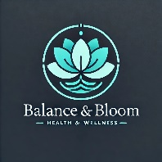
Health & Well-Being at Work – Group Session Request Form
Thank you for your interest in a 1.5-hour health and well-being session for your team. Please fill out the form below, and we will get back to you promptly to confirm details and availability.

Company & Contact Information
- Company Name:
- Contact Person:
- Job Title:
- Email Address:
- Phone Number:

Session Details
- Preferred Date(s) & Time(s):
- Number of Participants:
- Location: (On-site / Virtual - Please specify)
- Primary Goals for the Session: (Circle all that apply)
Ideas to reduce stress and burnout Encourage movement and posture awareness
Increase energy and focus Enhance work/life balance culture
Boost morale and engagement Enhance employee retention and satisfaction
Improve overall health Foster leadership and growth
Reduce sick days and absenteeism Help newly promoted employees manage potential new stressors

Custom Requests & Additional Information
Please give me specific challenges your team is facing that you’d like addressed.

Next Steps
Once we receive your request, we will contact you to finalize the details and discuss any customization options. We look forward to helping your team Balance & Bloom!

Balance & Bloom – Helping Professionals Reignite Their Spark
Please email this form back to:
Email: info@balanceandbloom.life
Phone: 610-360-7669

Other information you would like to share may be written or typed below.

